# 

He Restoreth Ministries, Inc

# Spring Update 2025

**Prayer Requests for HRM**

* Please pray for the retreat center and for the counseling Brent is doing online.
* Brent is encouraged about several online prayer and accountability groups with missionaries that he is involved with. Please pray this will be fruitful for God’s Kingdom.
* Pray for us as we strive to keep up with all the work needed on the property. We have piles to burn, the road needs work, and ditches need maintenance, etc.

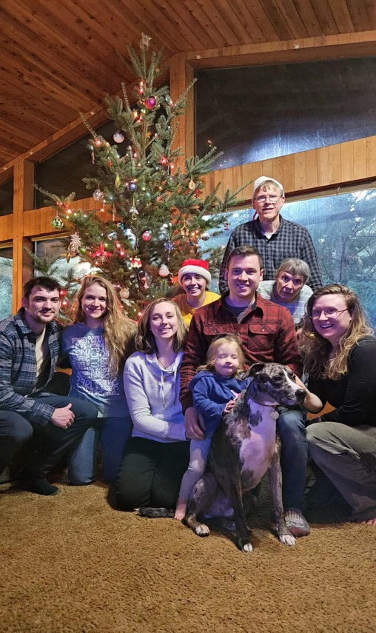**Family Prayer Request**

*Wedding!!*

Rebekah and Zach have decided to tie the knot! The wedding date is set for April 12. We are so excited! Please pray for all the wedding details and that God would richly bless their marriage. Pray for peace and a wedding that glorifies God.

Pray for Ruth, her health needs, and all the pain and challenges involved. Pray for peace as she watches without being able to do much to help!

Pray for Hannah and Elisabeth as they are doing a great deal to help with the wedding.

Pray for blessing and protection for Timothy and Ashley as they strive to raise Amelia and keep up with busy schedules.

Pray for me (Brent) that I will be sensitive to the Holy Spirit and trust Him. Pray that I will be wise and diligent as I strive to keep up with a busy work schedule and deal with back pain.

***Thanks for your prayers!***

*Thank you to those who are helping us and praying for this ministry*. Do pray for additional monthly support and one-time gifts. God is faithful and will provide. Let us know if you would like to be part of His provision.

Love in Christ,

Brent, Ruth, and family